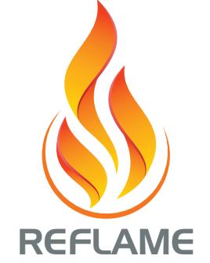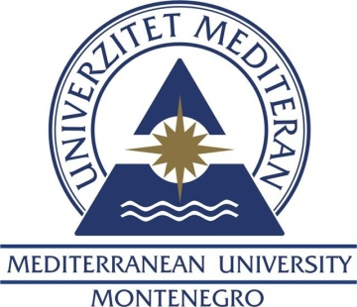
Summer school
Faculty of Foreign Languages, Mediterranean University
REFLAME YOUR ENGLISH FOR VISUAL ARTS

LSP Summer school
An intensive course in English for Visual Arts – B1/B2.1 level

Course duration: 10 working days (40 hours)
Target group and aims:
The course is primarily intended for the students of visual arts, but it can also be attended by all other students who want to improve their knowledge of the professional English and explore different areas of visual arts, which in itself is a symbiosis of art, science, Information Technology and other scientific and arts disciplines. The aims of the course are systematic development of all language skills (reading, listening, speaking and writing) at the B1/B2.1 level of the Common European Framework of Reference for Languages; introduction to professional terminology and narrowly-specific structures in the field of visual arts at all levels in written and oral communication; acquisition of grammatical knowledge, techniques and skills necessary for understanding professional texts, oral presentations on topics in the field of visual arts and writing for various art-related professional settings. The course is based on the textbook ReFLAME Your English for Visual Arts which offers a variety of the most relevant and up-to-date authentic teaching materials (texts, audio and video resources) encompassing different genres, a range of individual, pair and group activities for learning relevant vocabulary and grammar structures in context, skill-based and task-based activities selected in accordance with the demands of the labour market as well as mini-projects encouraging group work and autonomous learning.

Prerequisites for the course enrolment:
The A2 level of general English is needed to follow the course material.
Learning outcomes:
By the end of this course a student will be able to:

- demonstrate high levels of communicative competence in vocational English for visual arts at the B1/B2.1 level of the Common European Framework of Reference for Languages;
- use professional terminology and specific structures related to visual arts discourse in written and oral communication
- apply most important grammatical structures and specialised techniques and skills necessary for understanding professional texts and communicating in professional situations
- analyse the written or spoken text in detail and comprehensively and recognize key ideas and implicit meaning;
- give oral presentations and discuss topics related to the latest achievements in different areas of visual arts;
- write a range of texts necessary for creating a portfolio website and various art-related professional settings (an artist’s statement, an e-mail, a cover letter, a CV, a proposal, a report, a review, a summary essay)

